CONFIDENTIAL

PRE-EMPLOYMENT CERTIFICATE OF DENTAL FITNESS

Guidance notes - Candidate
One form will need to be completed per person; yourself as the candidate and any accompanying dependants.
On completion of the form by your Dental Practitioner, together with any supporting documentation (e.g. blood test results), please send directly to the St Helena Government United Kingdom Representative on the following email address: shgukrep@sthelenagov.com
Guidance notes – examining Dentist
The individual you are examining has applied for work on St Helena Island, South Atlantic for an extended period of time. Our dental facilities are limited to Primary Care. For this reason we wish to establish dental fitness prior to departing for St Helena. It is essential that avoidable emergencies do not occur in this remote location.
Please complete the attached form for the patient following a thorough dental examination including bitewing radiographs and a OPT where un-erupted, partially erupted, or problematic wisdom teeth are present.
We would emphasise the importance of restoring all carious lesions, removing teeth of poor prognosis and providing high quality root canal treatment where appropriate before declaring the individual to be dentally fit for deployment.
While St Helena offers a very good dental service, due to capacity problems, certain treatments are unable to be performed. The dental surgeon should ensure, before signing this form that any necessary remedial work has been completed and there is a reasonable likelihood of no further treatment being necessary for the next six months.
Individuals from 2 years old and above would be required to undergo dental assessment prior to arriving to St Helena.
Orthodontic treatment and crown and bridge treatment is not available on St Helena.
Any costs relating to the provision of this certificate shall be payable by the individual concerned in the usual way.

Section A | Personal Details

Applicant name as shown in passport:

Family/ Last Name
First Names

Gender Male Female

Date of birth: ----------- / -------------------/ ------------
Date Month Year
Section B | Dental Examination

Date and reason for last attendance:

Dental Charting:
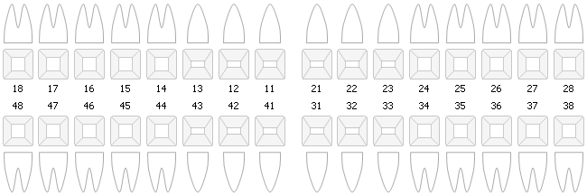
Please identify all areas of concern:

Please submit a report (or digital copies) of recent radiographs: bitewings less than 6 months old and
OPT where un-erupted, partially erupted or problematic wisdom teeth are present.

BPE:

3rd molars present:
Un-erupted |  | Partially Erupted |  | Erupted |  | Erupted and into occlusion

3rd molars symptomatic: Yes No

Poor | Moderate | Good
Oral hygiene status:

Section C | Examining Dentists declaration

I have examined this individual prior to travel to St Helena. All necessary treatment the patient is willing to undergo has been completed and I confirm that the patient is unlikely to require further
dental treatment in the next 6 months.

Signature of dental examiner:

Name of Dental Examiner:

Address of Dental Practice:

Date of examination:

Registration number and registering authority:

Issuing Authority Stamp:

