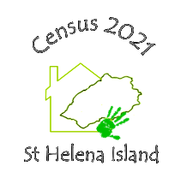
Dear respondent,
Thank you for taking the time to complete the 2020 St Helena Population and Housing Census pilot form, your input in this exercise is greatly appreciated.
We would be most grateful if you could complete the below relating to the pilot form. If you have any further comments please feel free to express them in the space provided overleaf.
2020 Pilot Census Questionnaire Feedback
Were there any questions that you feel were difficult to answer or understand? If so please list these in the table below and where possible provide details.
Question No. | Comment
Please provide any other comments here:

