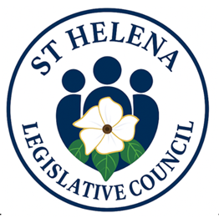
TERMS OF REFERENCE
DIASPORA CHAMPION

Background
Legislative Council recognises the critical role of diaspora communities in contributing to national development through remittances, investment, skills transfer, and advocacy - to enhance engagement and collaboration, and to strengthen partnerships between diaspora groups and local institutions.

Purpose of the Role

The purpose of the Diaspora Champion is to serve as a focal point for engaging with diaspora communities, fostering collaboration, promoting diaspora-led initiatives, and ensuring diaspora perspectives are integrated into development and policy processes.

Objectives:

- Communicate with St Helenians off Island, be it Ascension, UK, Falklands or any other destination
- The diaspora will not be restricted to the voter’s role
- Engaging to understand what would attract locals to return and what negatives they envisage
- Information sharing – what is happening in St Helena, including possible legislative changes to create an input conduit for the topic
- Posting of opportunities Island might have, jobs etc
- Engage with professionals overseas to seek assistance in some instances (professionals offering to assist locals on island)
- Offering a home away from home platform
- Create a positive space of debate and questions
- Advocate for diaspora inclusion in national development strategies and programs.
- Support mechanisms for diaspora investment, innovation, and knowledge exchange.

