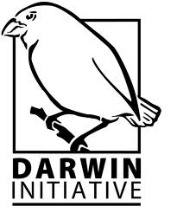Habitat Map Segment

Update Request Form
Date of submission of form *
Name of person/s submitting form*
Job title/interest
Job organisation/department/address*
Date of finding incorrect feature*:
GTN (ID) of segment*:
If you are reporting incorrect classification or attribute: |  |  |  | YES / NO
Current Habitat
(from existing habitat classification)
(eg 1.5.2 Eucalyptus Woodland):
Does this change of segment need a new habitat classification to define it? |  |  |  | YES / NO / UNSURE
Proposed Habitat
Reason of changing current habitat*
List GTNs (IDs) of any other segments with identical changes here (if applicable):
If you are reporting incorrect polygon or mapped area: |  |  |  | YES / NO
Please provide details of polygon amendments required in the box below
If possible provide annotated map or GIS shapefile
Please send completed form to imsgismanager@enrd.gov.sh
For GIS Office use only
Attribute | Old content | New content
UCC
GET
GTN
FCC1
FCC2
FCC3
FCC4
FTC
DFE
SRC
FEA
ASC
TPI
NPI
ANPI
DPI
CDA
IUCN1
IUCN2
IUCN3

Date Completed

