HEALTH MATTERS
As part of raising the issue of alcohol awareness the Health Promotion team are supporting two campaigns this month:
- Dry January - an annual campaign run by ‘Alcohol Concern’ to challenge people to give up alcohol for the 31 days of January.
- Love Your Liver - run by the “British Liver Trust.” This campaign encourages people to take 3 days off alcohol each week and to drink sensibly.
Health Promotion Coordinator, Marian Yon, said:
“We are not saying don’t go out and socialise but when you do, spread the word and encourage your friends to take the plunge as well.”
Dry January
Alcohol Concern’s Dry January is an annual campaign, but you can start at any time. But the challenge is still for 31 days! We want you to be able to go to that party …. but we want you to be able to do it alcohol free. When people ask why you aren’t drinking, you can bring them into the challenge as well.
Why Do Dry?
Dry January participants often report losing weight, sleeping better, having more energy and clearer skin - plus making huge savings. That’s not a bad return just for cutting out the booze for 31 days.
Important note: It’s worth stressing that Dry January is not a medical detox plan for those who are alcohol dependent. If you have been drinking heavily every day for many years, it might be worth consulting your GP before starting.
Drinking Myths
There are plenty of myths about alcohol and drinking. You might be surprised by how many things you think you know that are actually false. Find out what’s myth and what’s reality:

Myth 1: There is Nothing to be Done to Help a Problem Drinker

Many people are reluctant to admit they have a problem with alcohol. But every year people turn their lives around and take control of their drinking

Myth 2: A Trip to the Gym Will Undo Damage Caused by a Night on the Tiles

Exercise can make you feel a bit better after drinking, but it’s not possible to sweat out the alcohol. Only time will get it out of your bloodstream. Plus your risk of pulling a muscle when you’re working out is greater if you’ve been drinking (even the night before) or if you’re hung-over
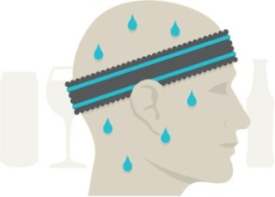
Myth 3: An Afternoon of Sport just isn’t Complete Without a Drink
- If you’re aiming to excel on the pitch, court or track, do not drink. Drinking before sport (even the night before you compete) will slow you down and increase your risk of injury and cramp. Plus it will dehydrate you
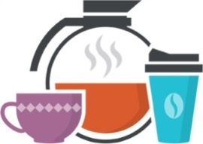
Myth 4: Coffee Sobers Me Up
- Drinking coffee makes you feel more awake, but won’t make you less drunk or cure a hangover. Drinking caffeine may also make it harder for you to realise whether you’re still drunk, leading to poor decision-making, such as driving whilst there’s still alcohol in your bloodstream
Myth 5: Drinking Helps Me Sleep
- Alcohol can make you feel sleepy, and help you get to sleep quickly. But it may also stop your body getting the deep sleep you need, leaving you tired the next morning
Myth 6: Alcohol Gives Me a Boost
- Alcohol is a depressant, and it slows down how you think, move and react. So it’s not the best way to pick yourself up
Myth 7: Alcohol Improves Sexual Performance
- Temporary impotence after a bout of drinking is pretty common amongst men. Long term, in both men and women, heavy drinking can lead to a loss of sexual drive
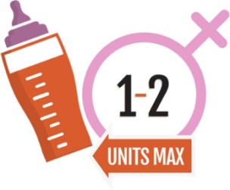
Myth 8: Drinking When Pregnant is OK
- Drinking alcohol when you’re pregnant can harm the foetus, particularly during the early stages of pregnancy. The best advice if you’re pregnant or trying to have a baby is to avoid alcohol altogether - which is often simpler than trying to stick to just one or two units a week
Myth 9: I Can Drink and Still be In Control
- Alcohol dulls your brain like an anaesthetic. It clouds your judgement, makes your more clumsy and slower to react. So your risk of accidents and injuries is much higher
Myth 10: I Can Save Up My Alcohol Units for the Weekend
- If you do drink, spread your units out through the week, with at least two alcohol-free days in every seven
SHG
18 January 2016

