HEALTH MATTERS
Do Something Good for You in 2016
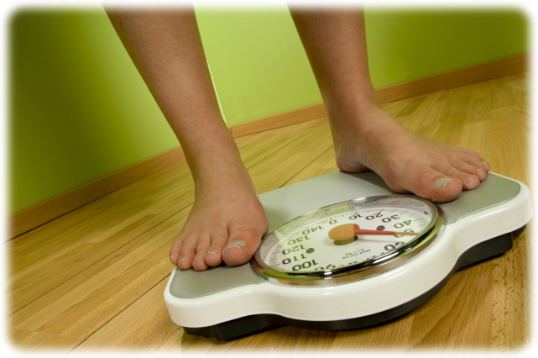
Most of us can be a little bit healthier. Whether it’s making changes to what we eat, drinking more water, or being a bit more physically active. There are lots of small changes we can all make to improve our long-term health.
It’s something we all need to think about. Not only can we improve our health, and that of our families and friends, we can also reduce demands on our hospital and health service.

So that’s what January should be about:
- Improving our health and making small changes that will help in the long term
So join us in making a healthy New Year’s Resolution for 2016 and do something good for you this January.
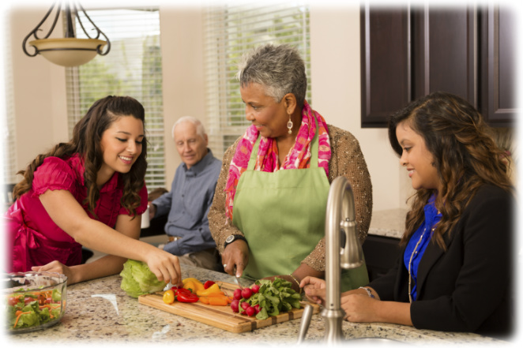
For further information or advice please contact:

Marian Yon on e-mail marian.yon@publichealth.gov.sh or

Marian Kanes on e-mail hp-trainer@publichealth,gov.sh
Marian Kanes, Health Promotion Trainer
SHG
11 January 2016

