HEALTH MATTERS
FESTIVE DRINKING
This week in the lead up to Christmas we are going to be looking at alcohol awareness. Many of us enjoy a drink, especially around the festive period, and while we don’t want to spoil your enjoyment of this time - we would like to help you stay safe and healthy.
You can be over the limit to drive on less alcohol than you may think. If you’re out celebrating over the festive period, DON’T DRINK IF YOU’RE DRIVING.
The drink drive limit on St Helena is 50 micrograms of alcohol per 100 millilitres of breath. If you’re asked to take a urine test, the limit is 153 milligrams of alcohol per 100 millilitres of urine, and for a blood test, the limit is 115 milligrams of alcohol per 100 millilitres of blood.
But it’s very difficult to judge when you've reached these limits.
Recommendations for Safe Drinking:
- Men should not regularly drink more than 3-4 units of alcohol a day
- Women should not regularly drink more than 2-3 units a day
- If you've had a heavy drinking session then avoid alcohol for the next 48 hours.
‘Regularly’ means drinking this amount every day or most days of the week.
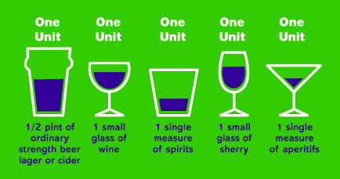

Alcohol affects each person differently. Many factors will influence the level of alcohol in your blood, such as your age, weight, how quickly your body breaks down chemicals, the type of drink, the speed of drinking and the amount that you've eaten.
Don’t Drink and Drive
Even a small amount of alcohol can affect your driving in a number of ways, including:
- Slower reactions
- Increased stopping distance
- Poorer judgment of speed and distance
- Reduced field of vision
Alcohol can also make you feel overconfident. This may make you more likely to take risks when driving, creating dangerous situations for yourself and other people on the road.
But if you drink before you drive you could still get caught, even if you don’t cause an accident. If you’re found guilty of driving over the alcohol limit, you could lose your licence, get a fine or even go to prison.
There are plenty of alternatives to drinking and driving that won’t spoil your fun. Why not take turns with your friends or family at being the Designated Driver?
Consider taking a taxi or agree in advance to stay at a friend’s house for the night. Make sure you only stay with someone you know and trust. If you've spent the evening drinking and you plan to drive the next day, it’s safest to allow at least 12 hours for the alcohol to leave your system. If you’ve drunk a lot, you may need even more time.
You may still be affected by alcohol the morning after. If you have a hangover, you’re driving ability may be impaired anyway. If you're stopped and given a breath test, you will be treated in the same way as if you were caught the night before.
If you're having a party at home, please also consider your guests who may not be drinking alcohol, and provide alternatives or make a non-alcoholic cocktail.
So from the Health Promotion Team have a very Happy Christmas and stay safe and healthy.
For further information please contact Marian Kanes, Health Promotion Trainer, at hp.trainer@publichealth.gov.sh, or Marian Yon, Health Promotion Coordinator, at marian.yon@publichealth.gov.sh. Alternatively you can call tel 22500, ext 211.
Marian Kanes, Health Promotion Trainer
SHG
14 December 2015

