

**HEALTH MATTERS**

***WEIGHT MANAGEMENT***

Following previous articles around healthy eating I thought that this week I would look at the Eatwell Plate which is a very visual and user friendly way, both to lose and maintain weight, by changing eating habits for life rather than dieting.

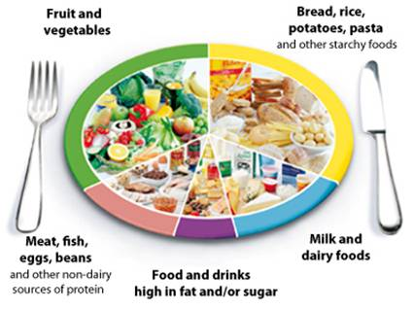

**The Eatwell Plate highlights the different types of food that make up our diet, and shows the proportions we should eat them in to have a healthy, balanced diet.**

It's a good idea to try to get this balance right every day, but you don't need to do it in every meal. You might find it easier to get the balance right over a longer period, like a week. And do try to choose options that are [lower in salt](http://www.nhs.uk/Livewell/Goodfood/Pages/cut-down-salt.aspx) when you can.

Eating healthily is about eating the right amount of food for your energy needs. On St Helena, many adults are either overweight or obese. This means many of us are eating more than we need, and should eat and drink fewer calories to lose weight.

Based on the Eatwell Plate try to eat the following foods in the proportions shown on the plate:

**Plenty of Fruit and Vegetables**

Did you know that we should be eating **at least five portions** of a variety of fruit and veg every day?

Consider frozen and tinned if no fresh fruit and vegetables are available.

**Plenty of Potatoes, Bread, Rice, Pasta and Other Starchy Foods**

Choose wholegrain varieties whenever you can, or eat potatoes with their skins on for more fibre.

**Some Milk and Dairy Foods**

Go for lower-fat milk and dairy foods. These are healthier options to help you get enough protein and calcium.

**Some Meat, Fish, Eggs, Beans and Other Non-dairy Sources of Protein**

These are important sources of protein, vitamins and minerals, and form part of a healthy, balanced diet.

**Just a Small Amount of Food and Drink that is High in Fat or Sugar**

You can cut down on fat and sugar by eating fewer sweets, cakes and biscuits, and drinking fewer sugary soft drinks, including energy drinks.  Remember that fruit juices can also be very high in sugar. Try to choose low sugar varieties of drink where possible.

## Is the Eatwell Plate for Me?

The Eatwell Plate applies to most of us - whether we're a healthy weight or overweight, whether we eat meat or are vegetarian.

However, the Eatwell Plate doesn't apply to children under the age of two, because they have different nutritional needs. From the ages of two to five, children should gradually move to eating the same foods as the rest of the family.

For further information please contact Marian Kanes, Health Promotion Trainer, at [hp.trainer@publichealth.gov.sh](mailto:hp.trainer@publichealth.gov.sh), or Marian Yon, Health Promotion Coordinator, at [marian.yon@publichealth.gov.sh](mailto:marian.yon@publichealth.gov.sh). Alternatively you can call tel 22500, ext 211.

**Marian Kanes**, **Health Promotion Trainer**

**SHG**

**7 December 2015**