HEALTH MATTERS
1 DECEMBER 2015 - WORLD AIDS DAY
What is HIV and AIDS?
HIV and AIDS is not the same thing and people who get an HIV infection do not automatically develop AIDS. HIV stands for Human Immunodeficiency Virus and weakens your ability to fight infections and disease generally.
Of the 2.1 million new infections recorded during 2013, 70 per cent occurred in Sub-Saharan Africa (WHO). This includes South Africa.

HIV is most commonly caught by having unprotected sex. So to stay safe, use protection!
There is no cure for HIV, but there are treatments to enable most people with the virus to live a long and healthy life.
AIDS stands for Acquired Immune Deficiency Syndrome - a term which covers a range of infections and illnesses which can result from a weakened immune system caused by HIV.
AIDS is the final stage of HIV infection, when your body can no longer fight life-threatening infections. With early diagnosis and effective treatment, most people with HIV will not go on to develop AIDS. There is usually a time lag of several years between first being infected with HIV and then developing infections and other AIDS-related problems. Because Antiretroviral Therapy (ART) has altered the way we think about the condition, the term ‘Late-stage HIV’ is being increasingly used instead of AIDS.
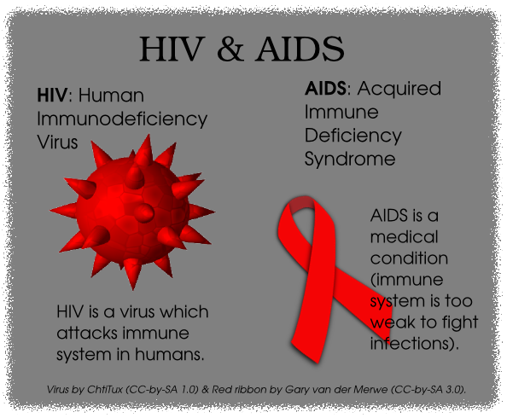

What if I don't like using protection i.e. condoms?

Condoms have come a long way in recent years and you can now get condoms in different sizes, flavours, and with added features to increase pleasure and heighten sensation. Condoms are still the best way to protect yourself and others from HIV infection, and other Sexually Transmitted Infections (STIs), so if you think you don't like using condoms, it's worth trying out some different varieties. Condoms can be found at clinics, the pharmacy and various bars on St Helena.
If you find using condoms or negotiating condom use with a partner difficult, it is worth speaking to your community nurse, doctor, or use the contact details below.
If someone with HIV also has an STI this can increase the amount of virus in their body. The more virus there is, the greater the risk of transmission to another person, so it is a good idea for sexually active people to get regular sexual health check-ups for both HIV and other STIs.
For further information please contact Marian Kanes, Health Promotion Trainer at hp.trainer@publichealth.gov.sh, or Marian Yon, Health Promotion Coordinator at marian.yon@publichealth.gov.sh. Alternatively you can call tel 22500, ext 211.
Marian Kanes, Health Promotion Trainer
SHG
23 November 2015

