HEALTH MATTERS

MEN’S HEALTH - ‘MOVEMBER’

November is Men’s Health Month and men all over the world are growing moustaches to raise awareness about men’s health issues. So men, why not join in and become a ‘Mo Bro’.

What is Movember All About?

Movember’s primary objective is to raise awareness around all men’s health issues, but specifically cancers affecting men. We want everyone to know that most cancers are highly curable if caught in the early stages - including prostate and testicular cancer. Movember aims to increase early detection, diagnosis and effective treatment, as this will ultimately reduce the number of deaths from cancer.

Rules for Movember

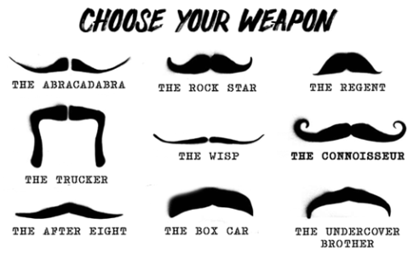
- Each Mo Bro must start on 1 November with a clean shaven face
- For the entire month of Movember each Mo Bro must grow and groom their moustache.
- Don’t fake it. No beards, no goatees, no fake moustaches.
- Use the power of the moustache to create conversations about men’s health and raise money for men’s health issues.
- Each Mo Bro must conduct himself like a true gentleman.

Startling Facts About Men’s Health

- 1 in 2 men will be diagnosed with cancer in their lifetime
- 1 in 7 men will be diagnosed with prostate cancer
- Testicular cancer is the most common cancer in males between the ages of 15 and 35
- Poor mental health affects men more than women - three quarters of suicides are by men. The World Health Organisation estimates that 510,000 men die from suicide globally each year. That’s one every minute.
- On average, across the world, men die six years earlier than women.

MOVE

Physical inactivity is a big deal. It’s the fourth leading risk factor for global mortality, causing 3.2 million deaths globally per year. This year Movember is launching MOVE a 30 day campaign to encourage physical activity. Although the focus for Movember is men’s health there is nothing to stop women getting involved as well. The aims of the MOVE campaign are to raise awareness of the dangers of physical inactivity and the benefits of exercise for both physical and mental health. It aims to find new ways to encourage physical activity and reduce the impact of a sedentary lifestyle.

St Helena is a beautiful island so enjoy it. Walking is one of the best activities there is and almost everyone can do it. If walking is not for you, think about joining a football or cricket team. We are surrounded by the sea and have a public swimming pool so perhaps swimming could be for you. The important thing is to incorporate some activity into your life.

What about Movember on St Helena?

It would be great if as many men (and women) as possible get involved with this. The whole reason for Movember is to raise awareness of men’s health issues. That’s not to say women’s health issues aren’t important, but there is lots of evidence that men are more reluctant to discuss health issues and seek help when needed. The aim is to get people talking about men’s health to raise awareness of the problems and the importance of seeking help early.

Let’s have lots of conversations about men’s health issues. It should be as acceptable to talk about impotence and testicular cancer as it is for women to talk about breast cancer and the menopause. It would also be great to see lots of men around the Island sporting moustaches and, if you are a lady, get behind your boyfriend or husband by telling him how handsome he looks in his moustache!

I will certainly be encouraging my husband, although you may have to take our word for it as we are off Island this month. Let’s fill Facebook with photos, and send pictures to the papers of Movember moustaches and activities on St Helena.
For further information, contact Marian Kanes, Health Promotion Trainer at hp.trainer@publichealth.gov.sh, or Marian Yon, Health Promotion Coordinator at marian.yon@publichealth.gov.sh.
Marian Kanes
Health Promotion Trainer
SHG
26 October 2015

