HEALTH MATTERS - USE OF CANNABIS
There has been a lot of information in the press lately about the use of cannabis on the Island, so I thought that I would put forward some information from a health perspective. My aim is to make this a balanced message based on the research available, to show that whilst cannabis is by no means one of the most dangerous illegal drugs around, it is certainly not risk free.
Cannabis (also known as Marijuana, Weed or Grass)
How cannabis makes you feel
The effects of cannabis vary from person to person:
- Some people may feel chilled out, relaxed and happy
- Others get the giggles or become more talkative
- Hunger pangs are common - sometimes known as ‘getting the munchies’
- You may become more aware of your senses - colours may look more intense and music may sound better
- It’s common to feel as though time is slowing down
Cannabis can have other effects too:
- It makes some people feel faint and/or sick - this is sometimes known as a ‘whitey’
- It can make you feel sleepy and lethargic
- Some people find it affects their memory, making it harder to remember things
- It makes some people feel confused, anxious or paranoid, and some experience panic attacks and hallucinations. These effects are particularly common with stronger forms of cannabis, such as skunk and sinsemilla
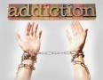
If you use cannabis regularly it can make you demotivated and uninterested in other things going on in your life, such as education or work. Long-term use can affect your ability to learn and to concentrate.
Can you get addicted to cannabis?
In the past cannabis wasn’t thought to be addictive. However, research has shown that it can be addictive, particularly if you have been using it regularly for quite a while. About 10% of regular cannabis users are thought to be dependent.
As with other addictive drugs such as cocaine and heroin, you can develop a tolerance to it. This means you have to have more and more to get the same effects. If you stop taking it, you can experience withdrawal symptoms, such as cravings, difficulty sleeping, mood swings and irritability.
If you regularly smoke cannabis with tobacco, you’re likely to get addicted to nicotine and may develop tobacco-related illnesses, such as cancer and coronary heart disease. If you cut down or give up, you will experience withdrawal from nicotine as well as cannabis.
Risks associated with cannabis
Recent research has helped us better understand the health risks from using cannabis. We know that:
- Cannabis affects your ability to drive - This is one of the reasons why drug driving, like drink driving, is illegal. One French study found that drivers who had been using cannabis were more than twice as likely to cause a fatal car crash. And you can still be unfit to drive the day after smoking cannabis.
- If you smoke it, cannabis can be harmful to your lungs - Like tobacco, it contains cancer-causing chemicals (carcinogens) that increase your risk of lung cancer. It can also make asthma worse, and cause wheezing in people without asthma. If you mix cannabis with tobacco and smoke it, the risks to your lungs are higher.
- Cannabis can harm your mental health - Cannabis plants produce a group of chemicals called cannabinoids, which produce mental and physical effects when consumed. Regular use is associated with an increased risk of developing a psychotic illness, such as schizophrenia. A psychotic illness is one where you experience hallucinations (when you see things that aren’t really there) and delusions (when you believe things that aren’t really true). Your risk of developing a psychotic illness is higher if you start using cannabis in your teens and if you have a family history of mental illness. Cannabis use has also been shown to increase the risk of a relapse in people who have schizophrenia, and could make existing symptoms worse.
- Cannabis may affect your fertility - Research done in animals suggests that cannabis can disrupt sperm production in males and ovulation in females.
- If you are pregnant, cannabis may harm your unborn baby - Research suggests that using cannabis during pregnancy could affect your baby's brain development. Regularly smoking cannabis with tobacco is associated with an increased risk of your baby being born small or premature.
Does my age affect my risks?
The risks linked to using cannabis do seem to be higher for people who use it regularly from an early age, including the risk of developing a mental illness. It’s not clear why the risks are higher for people who start using cannabis when young but it may be linked to the fact that, during the teenage years, the brain is still forming its connections and cannabis interferes with this process.
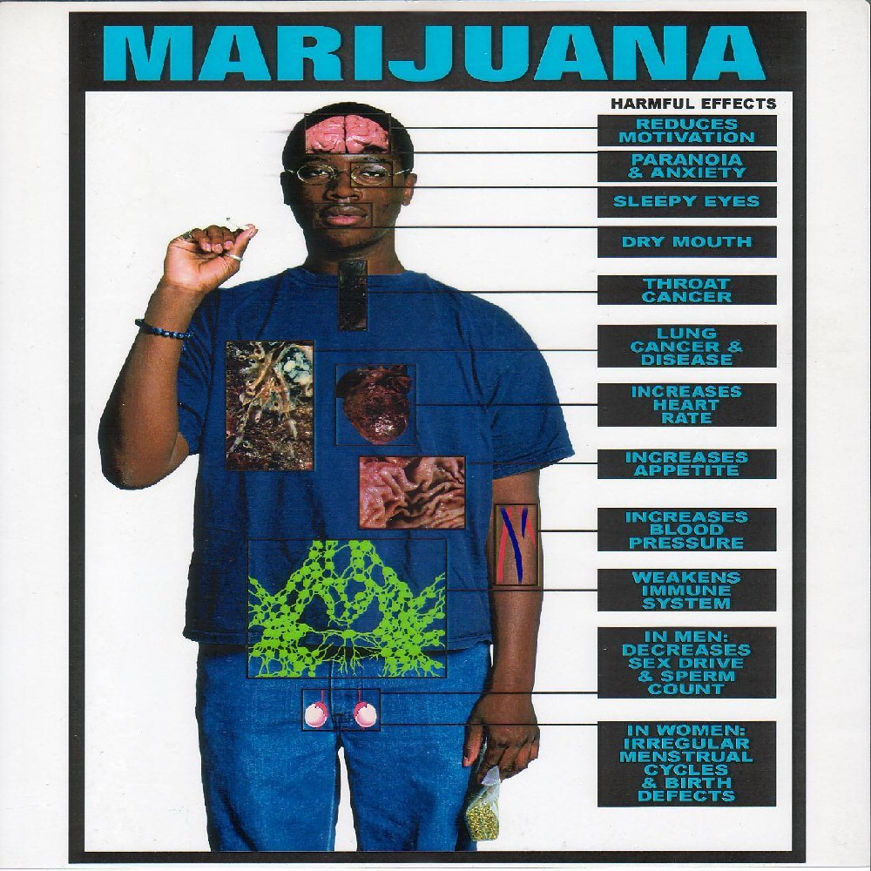
We will also be looking at the use of cannabis on our regular radio shows so do phone in with any comments or questions and we will try our best to answer them.
Marian Kanes
Health Promotion Trainer
SHG
7 September 2015

