HEALTH MATTERS
Hi,
My name is Marian Kanes and I am the new Health Promotion Trainer, based at St John’s Villa at the Hospital. I am hoping that this will be the first of many health articles.
I have been employed to work with you all to help you live a longer and healthier life. I am not here to tell you what to do, but rather work with you to raise awareness of health conditions and unhealthy behaviours. Most of us know the things that we are doing that are unhealthy for us, and in many cases are looking for a bit of help and support to change them. That is what I am here for!
If you are happy with your lifestyle, however unhealthy it may be, that is your decision to make and I respect that. But if there is something you would like help with, please contact me and I will do my best to ensure you get information and support, either from me or from one of my expert colleagues.
Donating Blood
For my first article I thought that I would start with a problem that was highlighted to me very soon after I started in my role - the need for more blood donors on St Helena.
Blood donation involves collecting blood from a donor so it can be used to treat someone else.
Blood donations are an essential part of our healthcare system. If we did not have volunteers giving blood, many medical procedures we take for granted could not take place here on the Island.
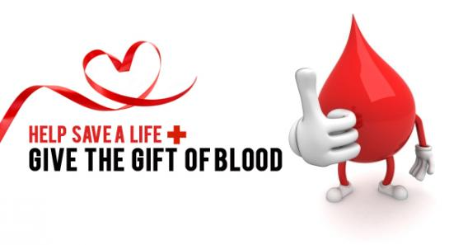

How is Donated Blood Used?
Doctors and surgeons rely on blood donations to carry out life-saving and life-enhancing treatments. In most cases, your blood will be separated into its component parts so it can be used to treat a variety of conditions. These components are:
- Red blood cells - used to treat some types of anaemia and replace blood lost as the result of an accident
- Platelets - used to treat problems with bone marrow, such as leukaemia and people with blood clotting disorders
- Plasma - used to treat conditions where abnormal clotting causes bleeding, such as liver disease, and where large volumes of blood have been lost.
Donated blood may also be used to improve the quality of life of people with a terminal illness.
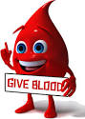

Who can donate blood?
Most people between the ages of 17 and 66 can donate blood, although you must be in good general health.
To reduce the risk to recipients of donated blood, there are rules about who can and cannot donate.
For example, people who have ever had HIV, syphilis or hepatitis C can never donate blood. Having a recent tattoo, piercing or taking certain medication, may also mean you cannot donate blood for a time.
If you are interested in donating blood please contact Geoff Benjamin on 22500, who can also give details of the rules. You will first be invited to have your blood screened before being added to the register of donors. You will then be contacted when blood of your blood type is required.
Until next time,
Marian Kanes
Health Promotion Trainer
SHG
6 July 2015

